**Extending the Reliability Model of Cellular Aging**

Jessica Christopher, Jessika Williams, Dr. Hong Qin, Spelman College Department of Biology

**Abstract**

For biological organisms, aging is the increasing risk of functional failure and can lead to sickness and ultimately death. Thus, discovering the manner by which cellular components of a biological system age is an important question. Biological aging can be characterized by the reliability model of cellular aging and the Gompertz model that indicates an exponential increase of mortality rate. Previous findings demonstrate a system with a random number of redundant components with constant failure rates. In order to give rise to the Gompertz model, there must be initial defects in the system. We found that heterogeneous components can also give rise to biological aging as described by the Gompertz model.

**Introduction**

Aging is defined as the increasing chance of failure with time. In the reliability model of cellular aging, components are considered functionally redundant, if one fails, the entire system does not die, because the components are connected in parallel. The system will only die when all of the components fail.

**Figure 1. Redundancy of a system’s components leads to aging.**

Machines with more redundancy in their systems begin life with a lower risk of failure than those with less redundancy.

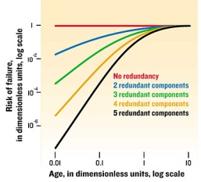

Redundancy decreases initial risk of failure/death and increases lifespan. In the human body, the cells that make up organs represent the components, and the organs represent the system. The individual components can either have the same failure rate (homogeneous) or different failure rates (heterogeneous). We are also studying the impact of varying functional modules and heterogeneous components on the emergence of biological aging characteristics, using R. R is software for statistical computing and graphics. Using R, we attempted to give rise to the Gompertz model.

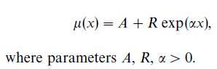

**Gompertz Law of Mortality**

**Time**

**Log of Failure Rate**

**Figure 2. (a) Gompertz model equation and parameters (b) Exponential increase of failure with age according to Gompertz model**

**Methods and Model**

R statistical programming language and environment was used to build a reliability mode. This model simulates the application of non-constant failure rates to the random, redundant components of a system.

Possion was used to simulate the initial defects in a system (the number of failed components). When a system already has several defects, and the probability that a component is functional is near zero, the simulation can give rise to the Gompertz model. Poisson model is a discreet probability model used to count variables with the assumption that the conditional means equal the conditional variances.

The codes used exhibited the method by which the lifespan of 15 systems with an original 50 components (can be altered in the code) was simulated with exponential failure rates applied. Further, the life span of the entire system was simulated for the total number of systems.

Poisson model – discreet probability model used to count variables with the assumption that the conditional means equal the conditional variances.

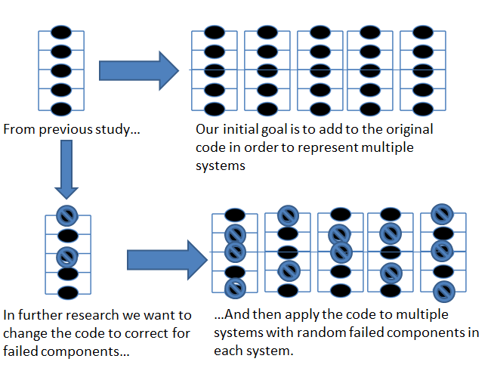

**Figure 3. Diagram of past, present, and future simulations**

**Results**

**Graphs 1-5. Increasing rate of failure with respect to age (time)**

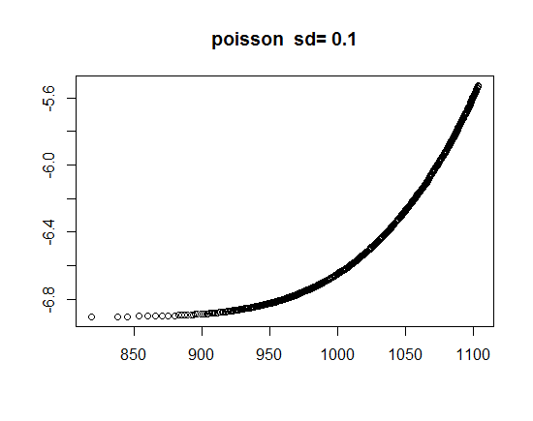 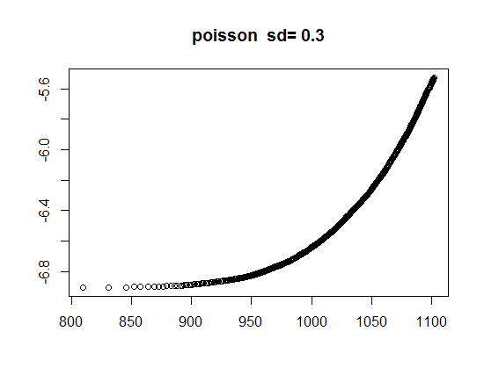 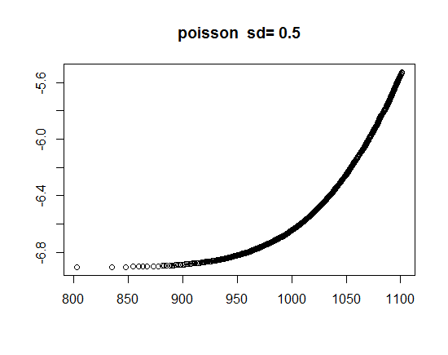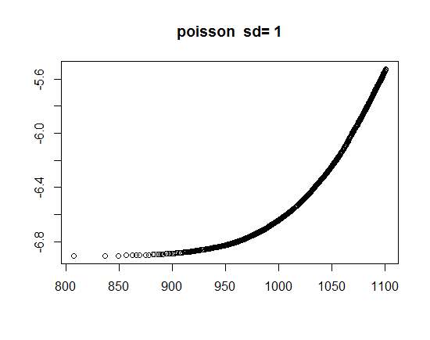 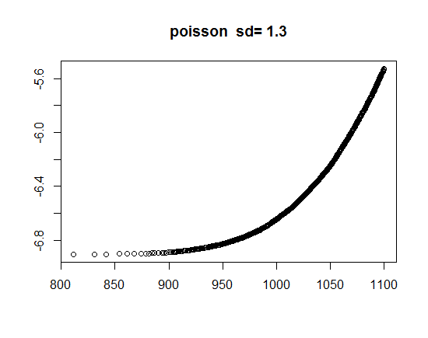 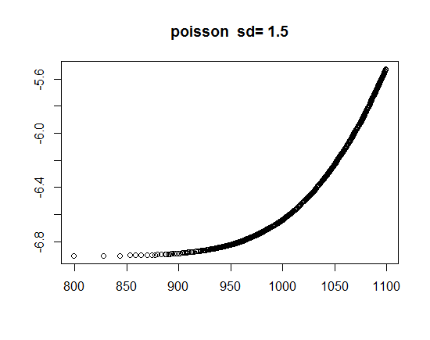

Time

Failure Rate

Failure Rate

Failure Rate

Failure Rate

Failure Rate

Failure Rate

Time

Time

Time

Time

Time

**Graphs 6-10. Exponentially decreasing viability with respect to age (time)**

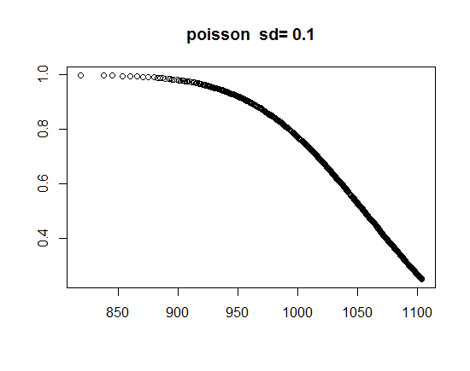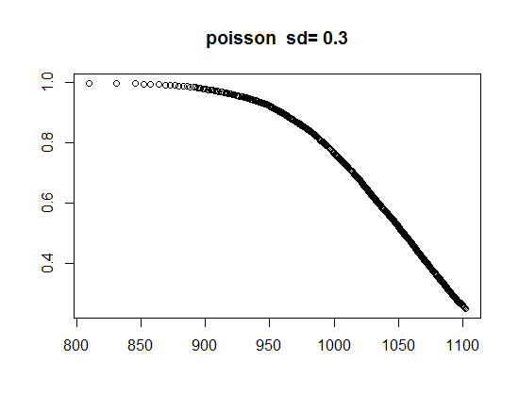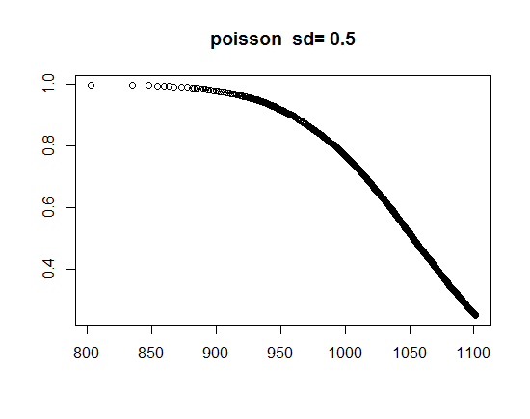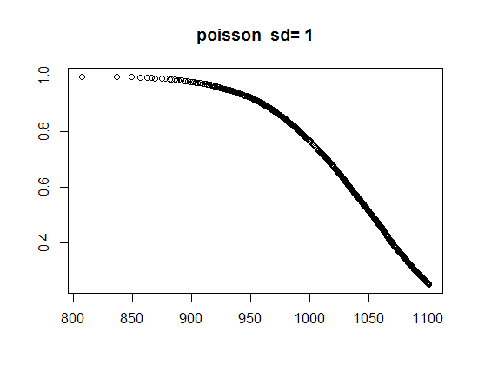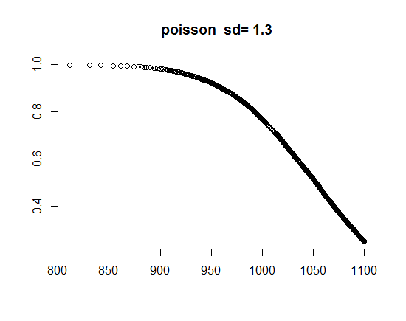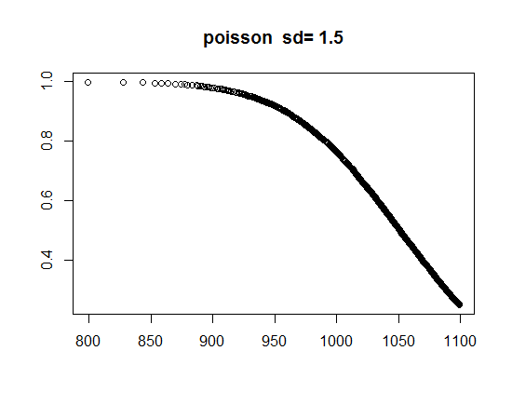

**Discussion, Conclusions and Future Work**

Simulations have shown that heterogeneity and initial defects simulated by poisson model can reproduce the exponentially increasing failure rates as dictated by the Gompertz Law of Mortality, the key biological feature of aging. Previous results show a correlation between standard deviation and the rate of aging. However, in recent experiments, the effect is not seen because the majority of the fluctuation comes from the poisson model as well as the noise added being too small.

We would like to simulate the leveling-off of the Reliability model which represents the late-life mortality deceleration and plateaus. This is a direct result of *redundancy exhaustion* in old age. In order to do that, a second population and repair mechanism must be introduced.

**References**

Gavrilov, Leonid., Gavrilova, Natalia., (2001). *The Reliability Theory of Aging and Longevity*. 528-536.

Gavrilov, Leonid., Gavrilova, Natalia. (2006). *Models of Systems Failure in Aging*. 47-51, 57-60.

Gavrilov, Leonid., Gavrilova, Natalia. (2003). *The Quest for a General Theory of Aging and Longevity*. 2-7.

Hellemans, Alexander, Mullins, Justin, Lal, Amit. *Why We Fall Apart*. IEEE Spectrum, Vol. 41, no. 9. September 2004, p. 3.

**Supplemental Information**

R code provided in “Supplemental R code 1”